Can I find half of a shape?

1. Colour in half of each shape.
2. b) c)
3. Circle the shapes that are half shaded.

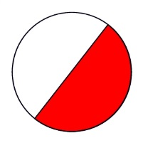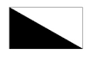[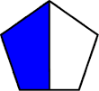](http://www.google.co.uk/url?url=http://www.edupic.net/fractions.htm&rct=j&frm=1&q=&esrc=s&sa=U&ved=0ahUKEwjLttXF4ovMAhVJtxoKHVLvAd4QwW4IGjAC&usg=AFQjCNHTCVpAI3bcA4_NWFL3ia2IX4TQAQ)

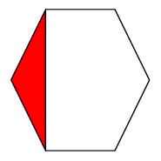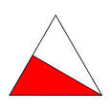

1. True or False?

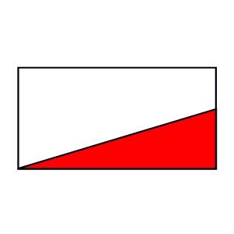Half of this shape is coloured in.

Explain your answer.

1. Can you split each of these shapes into two equal halves?

Explain why for each shape.