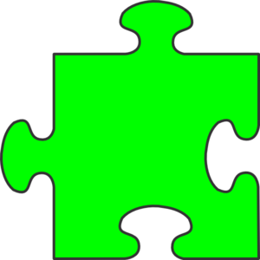

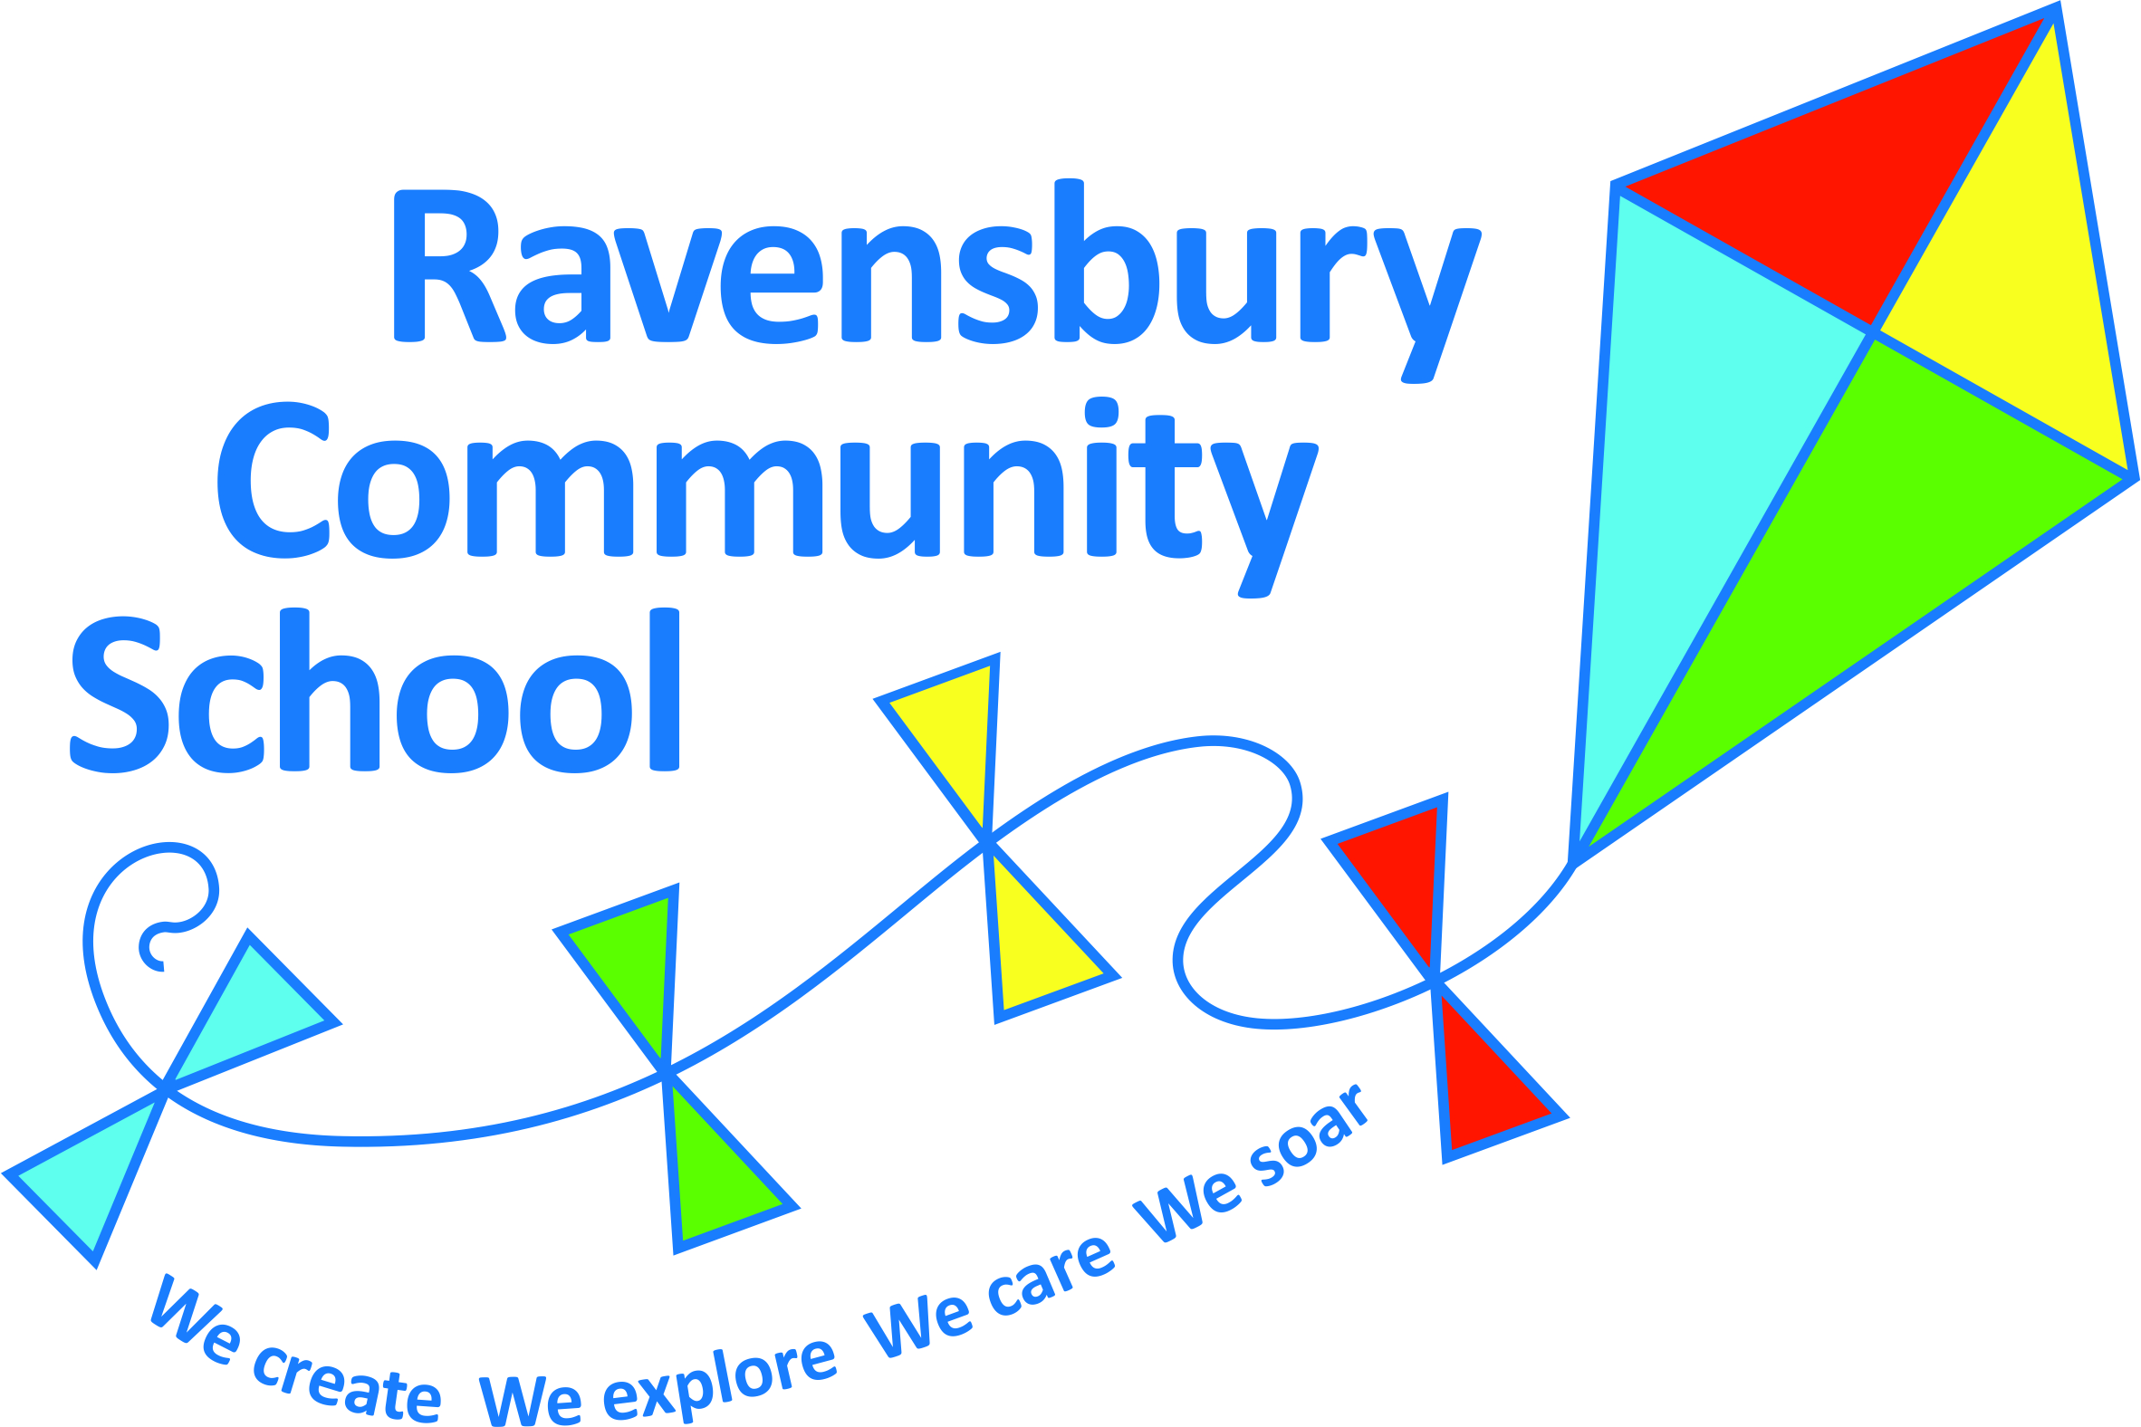

**School Improvement Plan 2024-2025**

**These are the things we will be working on this year.**

**Assessment tools and moderation**

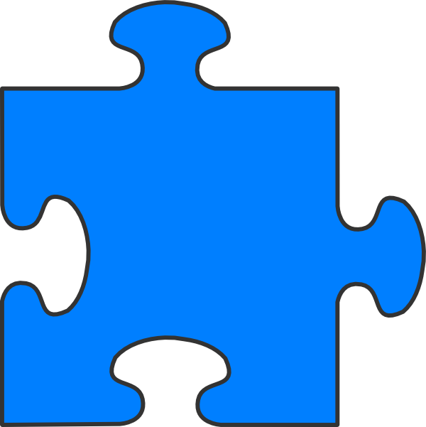 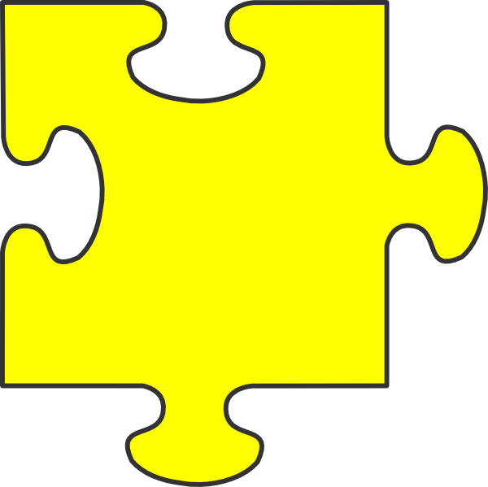

**Keep a look out for updates about how we are getting on in the newsletters!**

**Oracy and Spoken**

**Language**

**Behaviour and Attitudes to Learning**