**Assessment tools and moderation**

**Development of the Connected Curriculum**



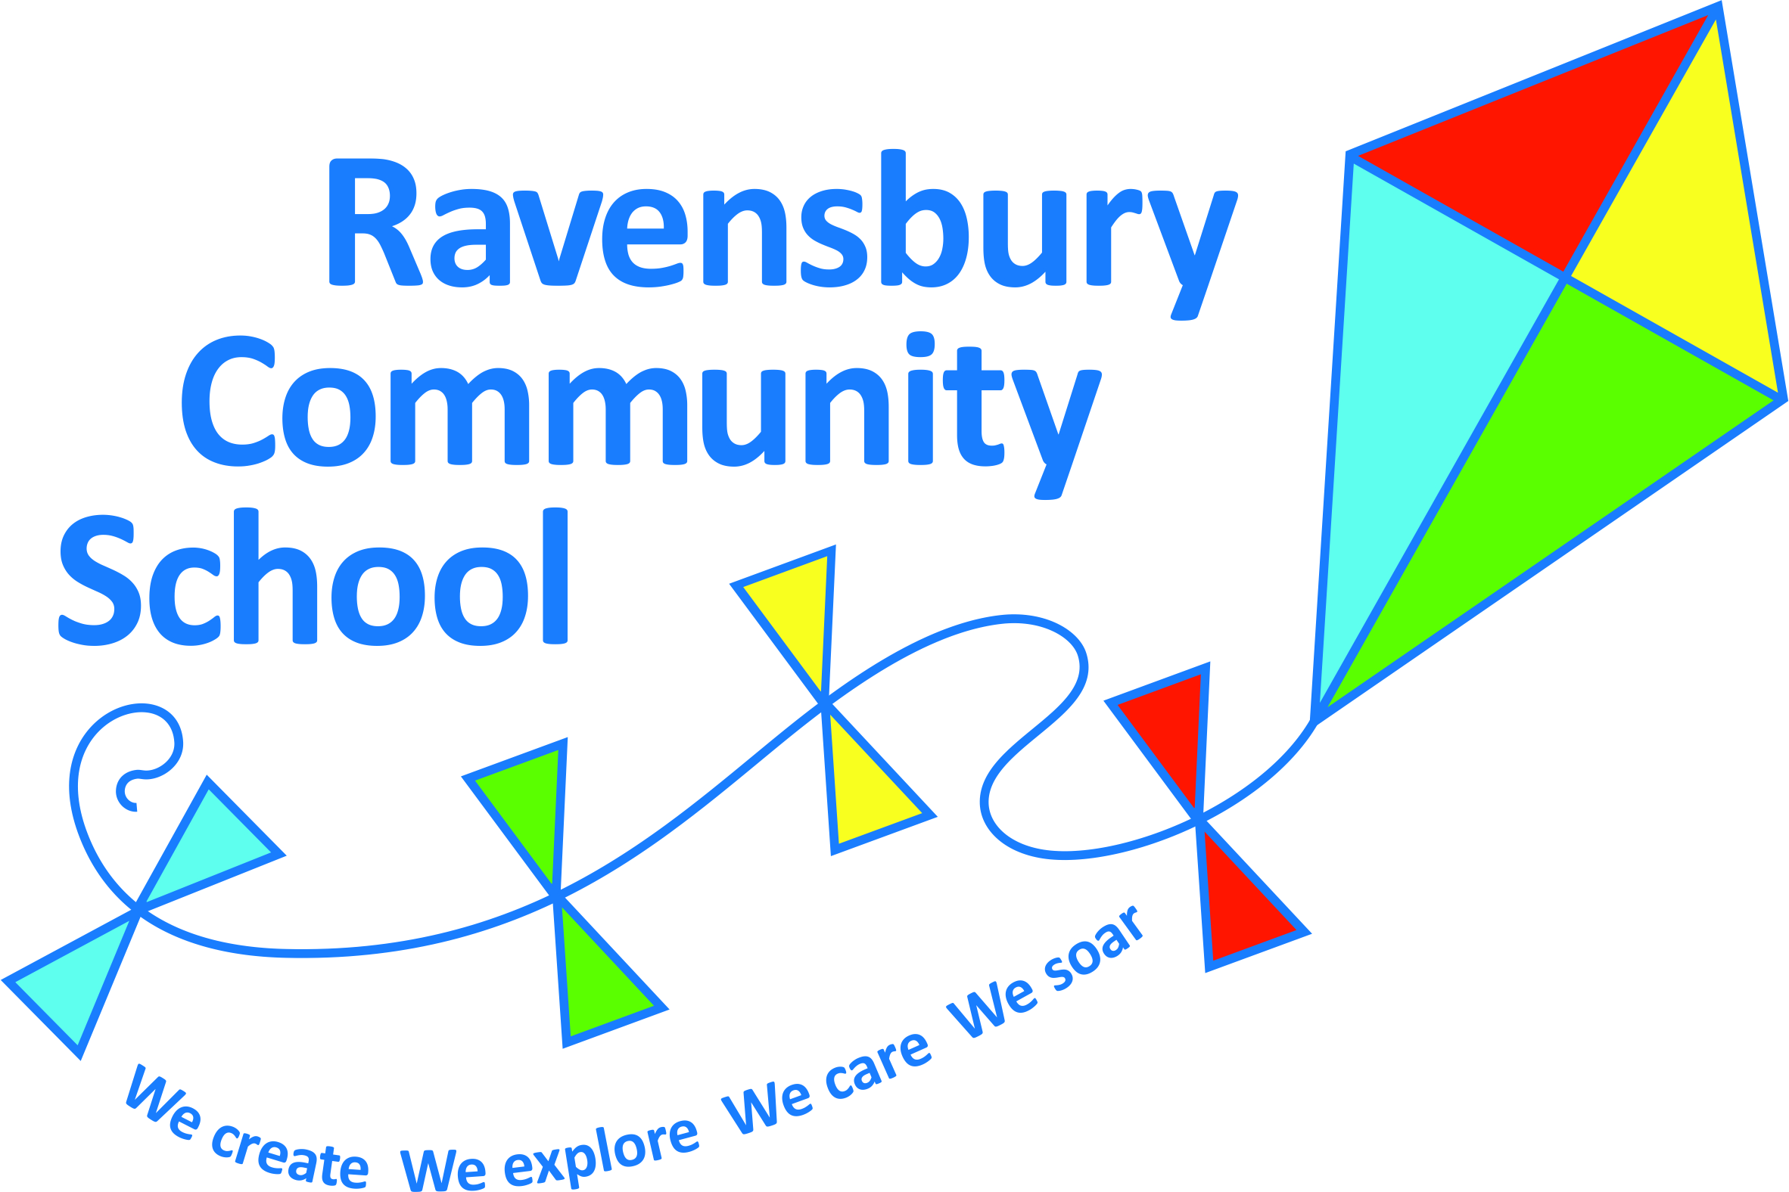

**School Improvement Plan 2023-2024**

**These are the things we will be working on this year.**

 

**Behaviour and attitudes to learning**



**Teaching and learning in writing**

**Keep a look out for updates about how we are getting on in the newsletters!**



 

**Development of the Connected Curriculum**

**Ensure that the learning points for each lesson are clear. Ensure that there is a progression of knowledge and skills across all foundation subjects so that they are built on year on year. Ensure that there are clear end points for each subject at the end of the lesson, unit,**

**key stage**

**Assessment tools and moderation**

**We will be reviewing the startegies we use to monitor and track the progress of our pupils.**

Let us know if your child is struggling with anything in school.

Ask you child what they have learned today

[](https://www.google.co.uk/url?sa=i&rct=j&q=&esrc=s&source=images&cd=&ved=2ahUKEwjN0IK7oeTkAhUixIUKHR2UCFUQjRx6BAgBEAQ&url=https://www.clipart.email/clipart/can-i-help-you-clipart-17653.html&psig=AOvVaw3OPxU6lF42jOSaIpeY0VWf&ust=1569235896185719)

Look at the half termly curriculum overviews.

Look out for our curriculum workshops!

Talk to your child about they are doing in school.

[](https://www.google.co.uk/url?sa=i&rct=j&q=&esrc=s&source=images&cd=&ved=2ahUKEwjN0IK7oeTkAhUixIUKHR2UCFUQjRx6BAgBEAQ&url=https://www.clipart.email/clipart/can-i-help-you-clipart-17653.html&psig=AOvVaw3OPxU6lF42jOSaIpeY0VWf&ust=1569235896185719)

 

**Behaviour and attitudes to learning**

**We will be reviewing out behaviour management policy and developing routines which outline how we expect the children to behave at different times. We will use reflective language and the language of choice. Your behaviour, your choice!**

If your child is rewarded for good behaviour ask they what they have done to receive this reward.

Look out for our behaviour workshops!

**Teaching and learning in writing**

**Staff will continue to develop**

**their skills in assessing**

**children’s writing. Children**

**will be given lots more opportunities to write a range**

**of different text types independently ranging from stories to reports and recounts.**

Encourage your child to write at home.

Encourage your child to learn their spellings.

[](https://www.google.co.uk/url?sa=i&rct=j&q=&esrc=s&source=images&cd=&ved=2ahUKEwjN0IK7oeTkAhUixIUKHR2UCFUQjRx6BAgBEAQ&url=https://www.clipart.email/clipart/can-i-help-you-clipart-17653.html&psig=AOvVaw3OPxU6lF42jOSaIpeY0VWf&ust=1569235896185719)

[](https://www.google.co.uk/url?sa=i&rct=j&q=&esrc=s&source=images&cd=&ved=2ahUKEwjN0IK7oeTkAhUixIUKHR2UCFUQjRx6BAgBEAQ&url=https://www.clipart.email/clipart/can-i-help-you-clipart-17653.html&psig=AOvVaw3OPxU6lF42jOSaIpeY0VWf&ust=1569235896185719)